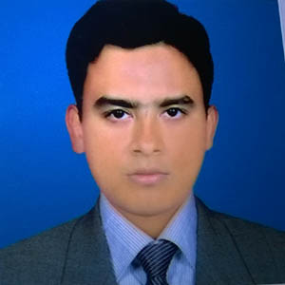**Cariculum Vitae**

**Of**

**Sheikh Al-Amin**

Contact : 01862-484838

* **Present Address :**

C/O-Late Md.Atiar Rahman

Village- Attaki

P.O.- Fakirhat

Upazilla- Fakirhat

District- Bagerhat.

* **Carrere Objective :**

To contribute in an organization where I can integrate my knowledge and skills to add value to the organization and explore my potentials.

* **Which things make me different :**

Hard working.

Time maintaining.

**Educational background :**

**Higher Secondary Certificate (H.S.C)**

Result : “A” G.P.A 4.19

Group : Computer Operation

Institution : Fakirhat Sheikh Hasina Technical College, Fakirhat, Bagerhat.

Board : Bangladesh Technical Education Board,Dhaka.

Passing Year : 2013

**Secondary School Certificate (S.S.C)**

Result : “C” G.P.A 2.81

Group : Science

Institution : Mulghor Govt High School, Mulghor ,Fakirhat.

Board : Jessore.

Passing Year : 2006

* **Computer Skills :**

Microsoft word, Microsoft Excel, Microsoft Access & Internet Browsing. IT Solution , Networking

* **Working Experience**

1. Worked in the ROBI Axiata Limited as a House Manager from 1st March 2012 to 15th July 2015.
2. Worked in the Khulna Shipyard Limited Bangladesh Navy, Khulna as a Record Keeper Cam Computer Operator From 15 July 2015 to 21 February 2017.
3. Worked in the Interspeed Marketing Solution Limited, As a Post Of BP Supervisor From 01 Oct 2017 to 01 August 2019.

* **Personal Information :**

Name : Sheikh AL-AMIN

Father’s Name : Late Sheikh Atiar Rahman

Mother’s Name : Shahina begum

Date of birth : 02 May, 1990.

Nationality : Bangladeshi By Birth.

Religion : Islam

Sex : Male

Marital Status : Single

Permanent Address : Village-Attaki, P.O.-Fakirhat, Upazilla-Fakirhat, Bagerhat.

* **References :**

**1.** SK. Bodiuzzaman (Jweel**)**

Distributor of ROBI,

Bagerhat district.

Cell-01836-066666.

I hereby declare that all the information stated above is true and correct, if you want I can prove it.



...............................................................

(Sheikh Al-Amin )

Date: …………..